Affine Transformation

Definition
# Source: AI Source: Provided by: [Data Path: Persons Table -> ID Column: 1, Name_En Column: Motasem Essam] -> From: [ChatGPT] on [7/25/2026]
An Affine Transformation is a geometric transformation that maps points from one affine space to another while preserving the fundamental properties of straight lines and parallelism.
In coordinate form, an affine transformation can be written as:
$$\boxed{x^{'}=Ax+b}$$
where:
- $x$is the original point,
- $x^{'}$is the transformed point,
- $A$is a linear transformation matrix,
- $b$is a translation vector.
For a two-dimensional point:
$$\left(\begin{matrix}x^{'} \\ y^{'}\end{matrix}\right)=A\left(\begin{matrix}x \\ y\end{matrix}\right)+\left(\begin{matrix}t_{x} \\ t_{y}\end{matrix}\right)$$
If:
$$A=\left(\begin{matrix}a & b \\ c & d\end{matrix}\right)$$
then:
$$\boxed{x^{'}=ax+by+t_{x}} \\ \boxed{y^{'}=cx+dy+t_{y}}$$

Simple Definition
# Source: AI Source: Provided by: [Data Path: Persons Table -> ID Column: 1, Name_En Column: Motasem Essam] -> From: [ChatGPT] on [7/25/2026]
An affine transformation is a transformation that can stretch, shear, rotate, reflect, and translate a figure while preserving straightness and parallelism.

Main Classification
# Source: AI Source: Provided by: [Data Path: Persons Table -> ID Column: 1, Name_En Column: Motasem Essam] -> From: [ChatGPT] on [7/25/2026]
A practical classification of affine transformations is:
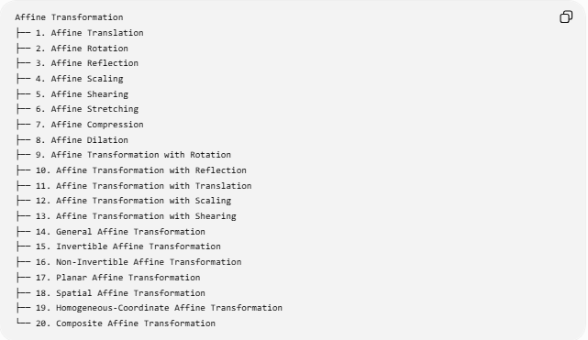
Affine Transformation
├── 1. Affine Translation
├── 2. Affine Rotation
├── 3. Affine Reflection
├── 4. Affine Scaling
├── 5. Affine Shearing
├── 6. Affine Stretching
├── 7. Affine Compression
├── 8. Affine Dilation
├── 9. Affine Transformation with Rotation
├── 10. Affine Transformation with Reflection
├── 11. Affine Transformation with Translation
├── 12. Affine Transformation with Scaling
├── 13. Affine Transformation with Shearing
├── 14. General Affine Transformation
├── 15. Invertible Affine Transformation
├── 16. Non-Invertible Affine Transformation
├── 17. Planar Affine Transformation
├── 18. Spatial Affine Transformation
├── 19. Homogeneous-Coordinate Affine Transformation
└── 20. Composite Affine Transformation
Some of these describe specific operations, while others describe the algebraic or geometric structure of the transformation.

1. Affine Translation
# Source: AI Source: Provided by: [Data Path: Persons Table -> ID Column: 1, Name_En Column: Motasem Essam] -> From: [ChatGPT] on [7/25/2026]
An affine translation moves every point by the same vector.
$$\left(x , y\right)→\left(x , +ay+b\right)$$
Example
$$\left(x , y\right)→\left(x , +4y-2\right)$$
For:
$$P=\left(2 , 5\right)$$
we obtain:
$$P^{'}=\left(6 , 3\right)$$
Preserves
- Straight lines
- Parallel lines
- Collinearity
- Ratios along the same line
It does not change:
- Lengths
- Angles
- Areas
because translation is also an isometry.

2. Affine Rotation
# Source: AI Source: Provided by: [Data Path: Persons Table -> ID Column: 1, Name_En Column: Motasem Essam] -> From: [ChatGPT] on [7/25/2026]
Rotation is an affine transformation.
A rotation by $θ$about the origin is:
$$\left(\begin{matrix}x^{'} \\ y^{'}\end{matrix}\right)=\left(\begin{matrix}\cos{θ} & -\sin{θ} \\ \sin{θ} & \cos{θ}\end{matrix}\right)\left(\begin{matrix}x \\ y\end{matrix}\right)$$
For a ${90}^{∘}$counterclockwise rotation:
$$\boxed{\left(x , y\right)→\left(- , yx\right)}$$
Example
$$P=\left(2 , 3\right)$$
becomes:
$$P^{'}=\left(- , 32\right)$$
Rotation preserves:
- Length
- Angles
- Parallelism
- Collinearity
- Area
Therefore, rotation is a special type of affine transformation.

3. Affine Reflection
# Source: AI Source: Provided by: [Data Path: Persons Table -> ID Column: 1, Name_En Column: Motasem Essam] -> From: [ChatGPT] on [7/25/2026]
Reflection is also an affine transformation.
For reflection across the $x$-axis:
$$\boxed{\left(x , y\right)→\left(x , -y\right)}$$
Example
$$P=\left(4 , 3\right)$$
becomes:
$$P^{'}=\left(4 , -3\right)$$
Reflection preserves:
- Straightness
- Parallelism
- Length
- Angle magnitude
- Area magnitude
but reverses orientation.

4. Affine Scaling
# Source: AI Source: Provided by: [Data Path: Persons Table -> ID Column: 1, Name_En Column: Motasem Essam] -> From: [ChatGPT] on [7/25/2026]
Scaling changes the size of a figure.
Uniform scaling about the origin:
$$\left(x , y\right)→\left(k , xky\right)$$
Example
For:
$$k=2 \\ \left(3 , 4\right)→\left(6 , 8\right)$$
Lengths are multiplied by:
$$k$$
and areas by:
$$k^{2}$$
For example, if $k=2$:
$$A^{'}=4A$$
Scaling preserves:
- Straight lines
- Parallelism
- Collinearity
- Ratios of lengths along the same line
- Angles, for uniform scaling
But general affine scaling does not necessarily preserve angles.

5. Affine Shearing
# Source: AI Source: Provided by: [Data Path: Persons Table -> ID Column: 1, Name_En Column: Motasem Essam] -> From: [ChatGPT] on [7/25/2026]
Shearing changes the position of points progressively according to their coordinates.
Horizontal shear
$$\boxed{\left(x , y\right)→\left(x , +kyy\right)}$$
Example
For:
$$k=2 \\ \left(3 , 4\right)→\left(3 , +2\left(4\right)4\right) \\ \boxed{\left(3 , 4\right)→\left(11 , 4\right)}$$
A square can become a parallelogram under shear.
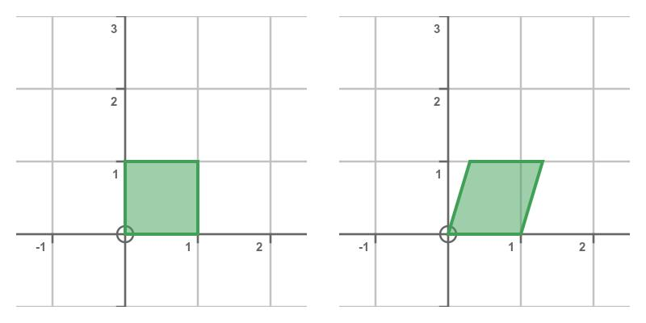
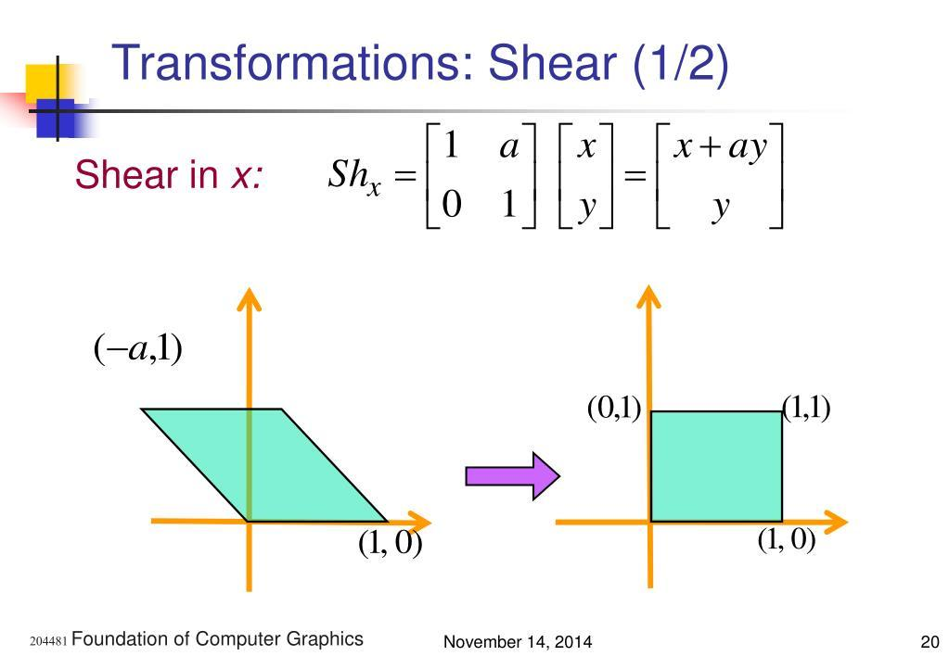
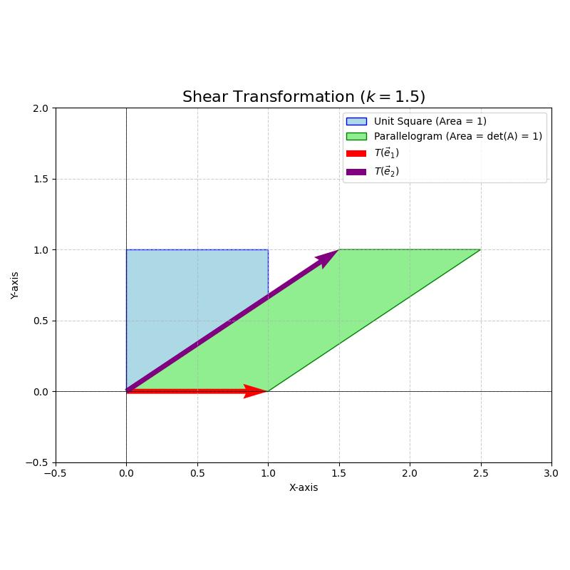
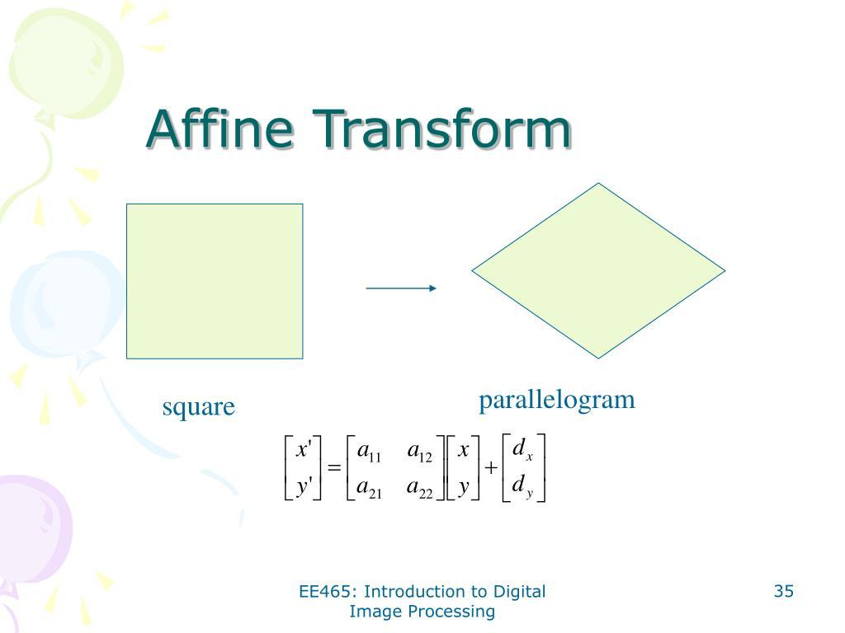
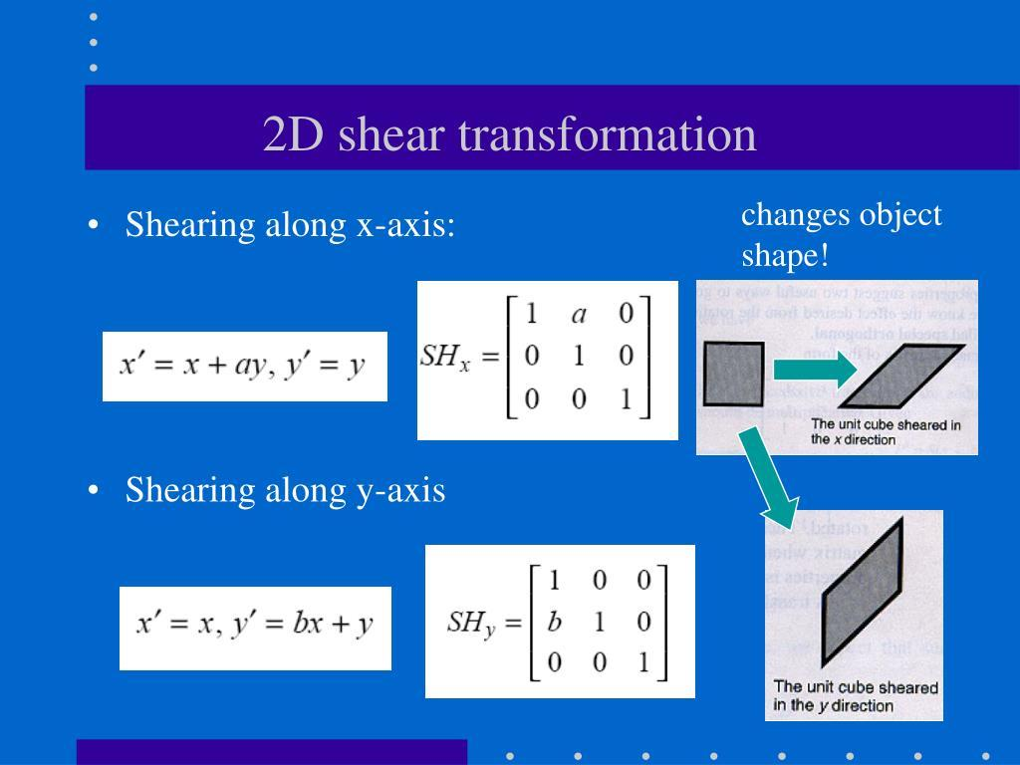
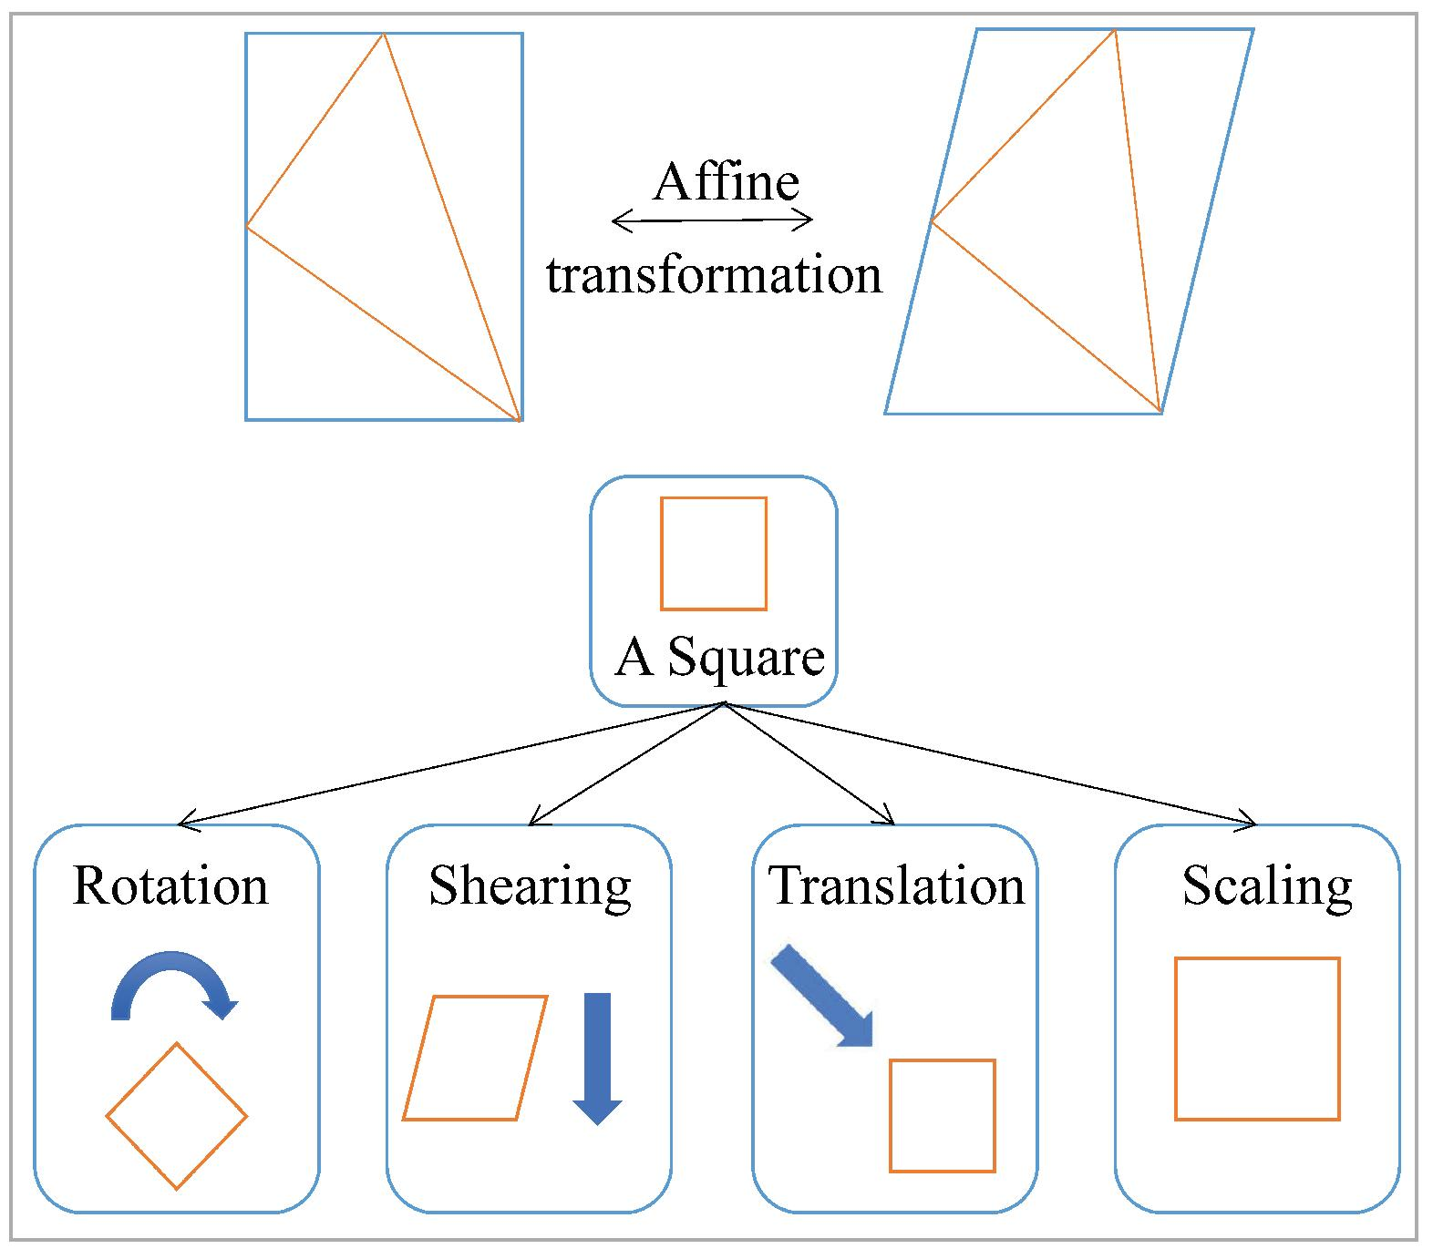
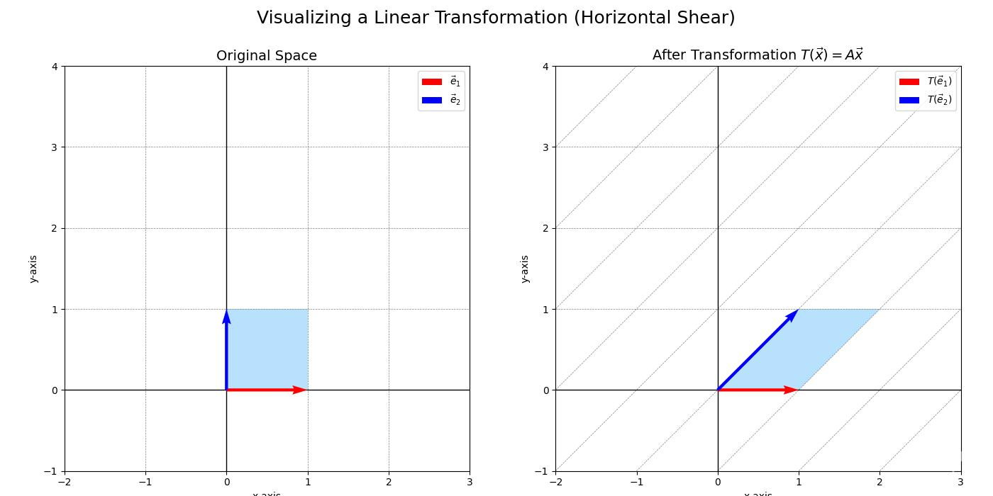
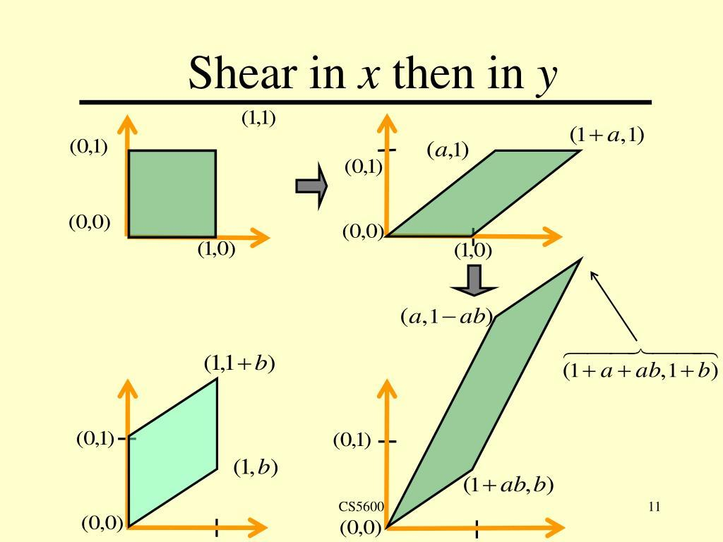
Important
Shearing generally changes:
- Angles
- Lengths
- Shape appearance
but preserves:
- Straight lines
- Parallelism
- Collinearity

6. Affine Stretching
# Source: AI Source: Provided by: [Data Path: Persons Table -> ID Column: 1, Name_En Column: Motasem Essam] -> From: [ChatGPT] on [7/25/2026]
An affine stretching scales coordinates by different factors.
For example:
$$\left(x , y\right)→\left(2 , x3y\right)$$
The $x$-direction is scaled by $2$, while the $y$-direction is scaled by $3$.
Example
$$P=\left(2 , 4\right)$$
becomes:
$$P^{'}=\left(4 , 12\right)$$
A square can become a rectangle.
Unlike uniform scaling, stretching generally does not preserve angles.

7. Affine Compression
# Source: AI Source: Provided by: [Data Path: Persons Table -> ID Column: 1, Name_En Column: Motasem Essam] -> From: [ChatGPT] on [7/25/2026]
Affine compression is scaling in one or more directions by factors smaller than $1$.
Example:
$$\left(x , y\right)→\left(\frac{1}{2} , x\frac{1}{3}y\right)$$
For:
$$P=\left(6 , 9\right)$$
we obtain:
$$P^{'}=\left(3 , 3\right)$$
It is essentially directional scaling with contraction.

8. Affine Dilation
# Source: AI Source: Provided by: [Data Path: Persons Table -> ID Column: 1, Name_En Column: Motasem Essam] -> From: [ChatGPT] on [7/25/2026]
A dilation centered at the origin is:
$$\left(x , y\right)→\left(k , xky\right)$$
This is an affine transformation because it has the form:
$$x^{'}=Ax$$
with:
$$A=\left(\begin{matrix}k & 0 \\ 0 & k\end{matrix}\right)$$
Example
For:
$$k=3 \\ \left(2 , 1\right)→\left(6 , 3\right)$$
A dilation preserves:
- Straight lines
- Parallelism
- Collinearity
- Angles
- Shape
but changes lengths and areas when $k≠1$.

9. Affine Transformation with Rotation
# Source: AI Source: Provided by: [Data Path: Persons Table -> ID Column: 1, Name_En Column: Motasem Essam] -> From: [ChatGPT] on [7/25/2026]
An affine transformation can combine rotation with scaling and/or shearing.
For example:
$$x^{'}=Ax$$
where:
$$A=\left(\begin{matrix}\cos{θ} & -\sin{θ} \\ \sin{θ} & \cos{θ}\end{matrix}\right)\left(\begin{matrix}k_{x} & 0 \\ 0 & k_{y}\end{matrix}\right)$$
This can rotate and stretch a figure.
Example
A circle under a suitable affine transformation can become an ellipse.

10. Affine Transformation with Reflection
# Source: AI Source: Provided by: [Data Path: Persons Table -> ID Column: 1, Name_En Column: Motasem Essam] -> From: [ChatGPT] on [7/25/2026]
An affine transformation may include a reflection.
For reflection across the $y$-axis:
$$\left(x , y\right)→\left(- , xy\right)$$
The corresponding matrix is:
$$A=\left(\begin{matrix}-1 & 0 \\ 0 & 1\end{matrix}\right)$$
Its determinant is:
$$det⁡\left(A\right)=-1$$
The negative determinant indicates orientation reversal.

11. Affine Transformation with Translation
# Source: AI Source: Provided by: [Data Path: Persons Table -> ID Column: 1, Name_En Column: Motasem Essam] -> From: [ChatGPT] on [7/25/2026]
A general affine transformation can include both a linear transformation and a translation:
$$\boxed{x^{'}=Ax+b}$$
Example
$$A=\left(\begin{matrix}2 & 0 \\ 0 & 3\end{matrix}\right)$$
and:
$$b=\left(\begin{matrix}4 \\ -1\end{matrix}\right)$$
Then:
$$x^{'}=2x+4 \\ y^{'}=3y-1$$
For:
$$P=\left(2 , 3\right) \\ P^{'}=\left(8 , 8\right)$$

12. Affine Transformation with Scaling
# Source: AI Source: Provided by: [Data Path: Persons Table -> ID Column: 1, Name_En Column: Motasem Essam] -> From: [ChatGPT] on [7/25/2026]
An affine transformation can scale the $x$and $y$directions differently:
$$\left(x , y\right)→\left(k_{x} , xk_{y}y\right)$$
For example:
$$\left(x , y\right)→\left(2 , x5y\right)$$
is affine.
The determinant is:
$$det⁡\left(A\right)=2\left(5\right)=10$$
Therefore, areas are multiplied by:
$$\boxed{10}$$

13. Affine Transformation with Shearing
# Source: AI Source: Provided by: [Data Path: Persons Table -> ID Column: 1, Name_En Column: Motasem Essam] -> From: [ChatGPT] on [7/25/2026]
Shearing can be represented by a matrix.
Horizontal shear
$$A=\left(\begin{matrix}1 & k \\ 0 & 1\end{matrix}\right)$$
Therefore:
$$\left(\begin{matrix}x^{'} \\ y^{'}\end{matrix}\right)=\left(\begin{matrix}1 & k \\ 0 & 1\end{matrix}\right)\left(\begin{matrix}x \\ y\end{matrix}\right)$$
giving:
$$x^{'}=x+ky \\ y^{'}=y$$
Vertical shear
$$A=\left(\begin{matrix}1 & 0 \\ k & 1\end{matrix}\right)$$
giving:
$$x^{'}=x \\ y^{'}=kx+y$$

14. General Affine Transformation
# Source: AI Source: Provided by: [Data Path: Persons Table -> ID Column: 1, Name_En Column: Motasem Essam] -> From: [ChatGPT] on [7/25/2026]
The most general two-dimensional affine transformation is:
$$\boxed{\begin{aligned}x^{'}&=ax+by+c \\ y^{'}&=dx+ey+f\end{aligned}}$$
or:
$$\boxed{x^{'}=Ax+b}$$
where:
$$A=\left(\begin{matrix}a & b \\ d & e\end{matrix}\right)$$
and:
$$b=\left(\begin{matrix}c \\ f\end{matrix}\right)$$
Example
$$x^{'}=2x+y+3 \\ y^{'}=x-2y+1$$
This is a general affine transformation.

15. Invertible Affine Transformation
# Source: AI Source: Provided by: [Data Path: Persons Table -> ID Column: 1, Name_En Column: Motasem Essam] -> From: [ChatGPT] on [7/25/2026]
An affine transformation is invertible when its matrix $A$is invertible.
For a $2×2$matrix:
$$A=\left(\begin{matrix}a & b \\ c & d\end{matrix}\right)$$
the condition is:
$$\boxed{ad-bc≠0}$$
or:
$$\boxed{det⁡\left(A\right)≠0}$$
The inverse is:
$$\boxed{x=A^{-1}\left(x^{'}-b\right)}$$
Example
If:
$$A=\left(\begin{matrix}2 & 0 \\ 0 & 3\end{matrix}\right)$$
then:
$$det⁡\left(A\right)=6≠0$$
so the transformation is invertible.

16. Non-Invertible Affine Transformation
# Source: AI Source: Provided by: [Data Path: Persons Table -> ID Column: 1, Name_En Column: Motasem Essam] -> From: [ChatGPT] on [7/25/2026]
An affine transformation is non-invertible when:
$$det⁡\left(A\right)=0$$
This means the transformation collapses some dimension.
Example
Consider:
$$\left(x , y\right)→\left(x , 0\right)$$
The entire plane is collapsed onto the $x$-axis.
Points such as:
$$\left(1 , 2\right), \left(1 , 5\right), \left(1 , 100\right)$$
all become:
$$\left(1 , 0\right)$$
Therefore, the original points cannot be uniquely recovered.
So no inverse exists.

17. Planar Affine Transformation
# Source: AI Source: Provided by: [Data Path: Persons Table -> ID Column: 1, Name_En Column: Motasem Essam] -> From: [ChatGPT] on [7/25/2026]
A planar affine transformation operates in two-dimensional space:
$$R^{2}→R^{2}$$
with:
$$x^{'}=Ax+b$$
It can transform:
- Points
- Lines
- Segments
- Polygons
- Circles
- Ellipses
- Other planar figures

18. Spatial Affine Transformation
# Source: AI Source: Provided by: [Data Path: Persons Table -> ID Column: 1, Name_En Column: Motasem Essam] -> From: [ChatGPT] on [7/25/2026]
Affine transformations also exist in three-dimensional space.
$$\boxed{x^{'}=Ax+b}$$
where:
$$x=\left(\begin{matrix}x \\ y \\ z\end{matrix}\right)$$
and $A$is a $3×3$matrix.
Example
$$\left(x , y , z\right)→\left(2 , x , y+3z-1\right)$$
This transformation can scale and translate points in space.

19. Homogeneous-Coordinate Affine Transformation
# Source: AI Source: Provided by: [Data Path: Persons Table -> ID Column: 1, Name_En Column: Motasem Essam] -> From: [ChatGPT] on [7/25/2026]
Affine transformations can be represented using homogeneous coordinates.
A 2D point:
$$\left(x , y\right)$$
is represented as:
$$\left(\begin{matrix}x \\ y \\ 1\end{matrix}\right)$$
An affine transformation can then be written as:
$$\left(\begin{matrix}x^{'} \\ y^{'} \\ 1\end{matrix}\right)=\left(\begin{matrix}a & b & c \\ d & e & f \\ 0 & 0 & 1\end{matrix}\right)\left(\begin{matrix}x \\ y \\ 1\end{matrix}\right)$$
This representation is especially useful when combining several affine transformations using matrix multiplication.

20. Composite Affine Transformation
# Source: AI Source: Provided by: [Data Path: Persons Table -> ID Column: 1, Name_En Column: Motasem Essam] -> From: [ChatGPT] on [7/25/2026]
Several affine transformations can be combined into one affine transformation.
Suppose:
$$T_{1}\left(x\right)=A_{1}x+b_{1}$$
and:
$$T_{2}\left(x\right)=A_{2}x+b_{2}$$
Then:
$$T_{2}\left(T_{1}\left(x\right)\right)=A_{2}A_{1}x+A_{2}b_{1}+b_{2}$$
which is again affine.
Therefore:
$$\boxed{\text{Composition of affine transformations is affine}}$$

What an Affine Transformation Preserves
# Source: AI Source: Provided by: [Data Path: Persons Table -> ID Column: 1, Name_En Column: Motasem Essam] -> From: [ChatGPT] on [7/25/2026]
This is one of the most important parts of affine geometry.
An invertible affine transformation preserves:

1. Straight Lines
# Source: AI Source: Provided by: [Data Path: Persons Table -> ID Column: 1, Name_En Column: Motasem Essam] -> From: [ChatGPT] on [7/25/2026]
A line remains a line.
$$\boxed{\text{Line}→\text{Line}}$$
It does not generally turn a line into a curve.

2. Collinearity
# Source: AI Source: Provided by: [Data Path: Persons Table -> ID Column: 1, Name_En Column: Motasem Essam] -> From: [ChatGPT] on [7/25/2026]
If three points lie on one line:
$$A,B,C\text{ are collinear}$$
then after an affine transformation:
$$A^{'},B^{'},C^{'}$$
remain collinear.

3. Parallelism
# Source: AI Source: Provided by: [Data Path: Persons Table -> ID Column: 1, Name_En Column: Motasem Essam] -> From: [ChatGPT] on [7/25/2026]
If:
$$l_{1}∥l_{2}$$
then:
$$T\left(l_{1}\right)∥T\left(l_{2}\right)$$
for an invertible affine transformation.

4. Ratios Along a Line
# Source: AI Source: Provided by: [Data Path: Persons Table -> ID Column: 1, Name_En Column: Motasem Essam] -> From: [ChatGPT] on [7/25/2026]
If $P$divides $AB$in a fixed ratio:
$$\frac{AP}{PB}=k$$
then the corresponding transformed point preserves that ratio.

5. Midpoints
# Source: AI Source: Provided by: [Data Path: Persons Table -> ID Column: 1, Name_En Column: Motasem Essam] -> From: [ChatGPT] on [7/25/2026]
If:
$$M=\frac{A+B}{2}$$
then:
$$M^{'}=\frac{A^{'}+B^{'}}{2}$$
Therefore affine transformations preserve midpoints.

6. Convexity
# Source: AI Source: Provided by: [Data Path: Persons Table -> ID Column: 1, Name_En Column: Motasem Essam] -> From: [ChatGPT] on [7/25/2026]
An invertible affine transformation preserves convexity.
A convex polygon remains convex.

7. Dimension
# Source: AI Source: Provided by: [Data Path: Persons Table -> ID Column: 1, Name_En Column: Motasem Essam] -> From: [ChatGPT] on [7/25/2026]
An invertible affine transformation preserves dimension.
For example:
$$\text{line}→\text{line} \\ \text{plane}→\text{plane}$$

What an Affine Transformation Does Not Generally Preserve
# Source: AI Source: Provided by: [Data Path: Persons Table -> ID Column: 1, Name_En Column: Motasem Essam] -> From: [ChatGPT] on [7/25/2026]
Unlike an isometry, a general affine transformation does not necessarily preserve:
- Lengths
- Angles
- Circles
- Perpendicularity
- Exact area
- Shape in the Euclidean sense
For example, a circle may become an ellipse.
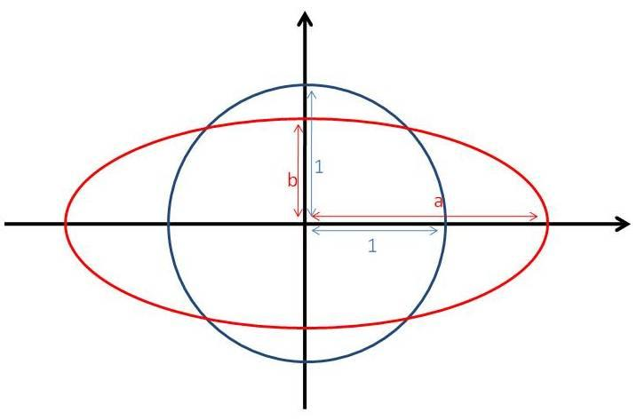
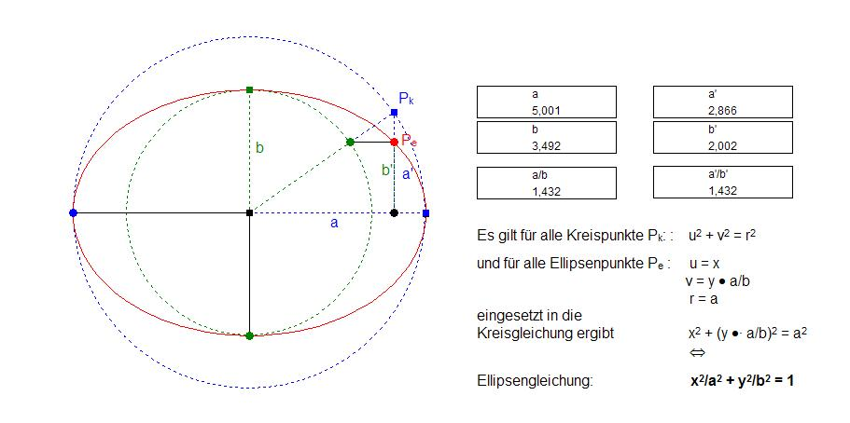
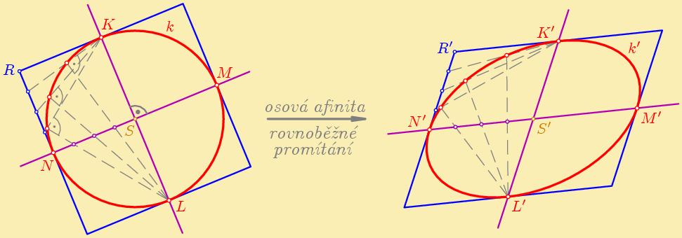
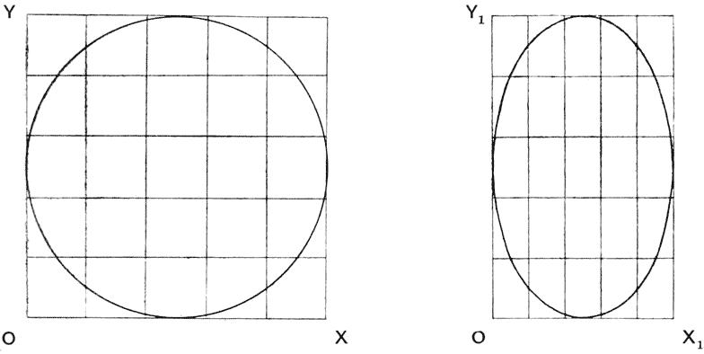
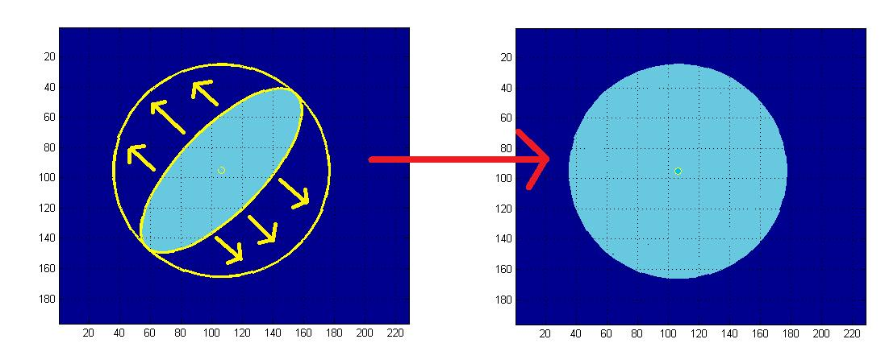
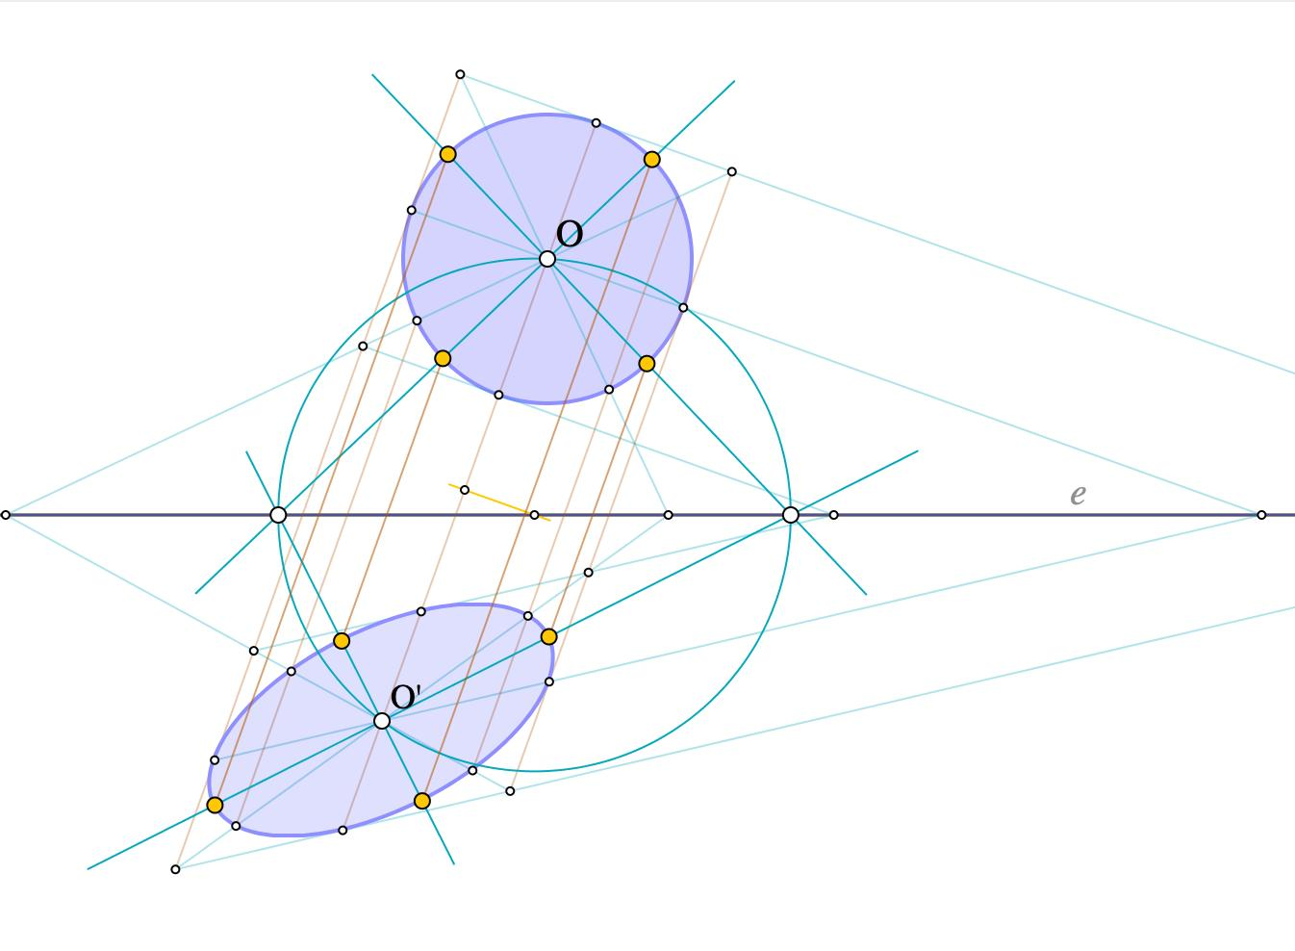
However, area changes predictably.
If:
$$A^{'}=Adet⁡\left(M\right)$$
then in terms of area magnitude:
$$\boxed{∣A^{'}∣=∣det⁡\left(M\right)∣A}$$
where $M$is the linear part of the affine transformation.

Affine Transformation of a Line
# Source: AI Source: Provided by: [Data Path: Persons Table -> ID Column: 1, Name_En Column: Motasem Essam] -> From: [ChatGPT] on [7/25/2026]
Suppose a line is parameterized by:
$$x\left(t\right)=p+tv$$
Apply:
$$T\left(x\right)=Ax+b$$
Then:
$$T\left(x\left(t\right)\right)=A\left(p+tv\right)+b \\ =\left(Ap+b\right)+t\left(Av\right)$$
This is still a line.
Therefore:
$$\boxed{\text{Affine transformations map lines to lines}}$$

Affine Transformation of a Triangle
# Source: AI Source: Provided by: [Data Path: Persons Table -> ID Column: 1, Name_En Column: Motasem Essam] -> From: [ChatGPT] on [7/25/2026]
A triangle remains a triangle under an invertible affine transformation.
For example:
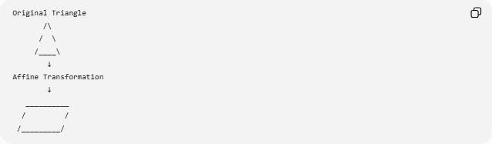
Original Triangle
/\
/ \
/____\
↓
Affine Transformation
↓
__________
/ /
/_________/
The triangle may change:
- Side lengths
- Angles
- Shape
but its vertices remain non-collinear and its sides remain straight.

Affine Transformation of a Circle
# Source: AI Source: Provided by: [Data Path: Persons Table -> ID Column: 1, Name_En Column: Motasem Essam] -> From: [ChatGPT] on [7/25/2026]
A general affine transformation maps a circle to an ellipse, unless the transformation has special properties.
For example:
$$\left(x , y\right)→\left(2 , xy\right)$$
applied to:
$$x^{2}+y^{2}=1$$
gives:
$${\left(\frac{x^{'}}{2}\right)}^{2}+y^{'2}=1$$
so:
$$\boxed{\frac{x^{'2}}{4}+y^{'2}=1}$$
This is an ellipse with semi-axes:
$$2, 1$$

Affine Transformation vs Other Transformations
# Source: AI Source: Provided by: [Data Path: Persons Table -> ID Column: 1, Name_En Column: Motasem Essam] -> From: [ChatGPT] on [7/25/2026]
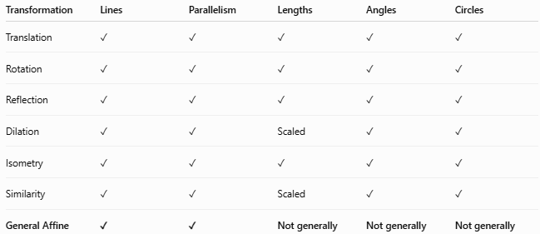
Transformation | Lines | Parallelism | Lengths | Angles | Circles
Translation | ✓ | ✓ | ✓ | ✓ | ✓
Rotation | ✓ | ✓ | ✓ | ✓ | ✓
Reflection | ✓ | ✓ | ✓ | ✓ | ✓
Dilation | ✓ | ✓ | Scaled | ✓ | ✓
Isometry | ✓ | ✓ | ✓ | ✓ | ✓
Similarity | ✓ | ✓ | Scaled | ✓ | ✓
General Affine | ✓ | ✓ | Not generally | Not generally | Not generally
The key distinction is:
$$\boxed{\text{Affine transformations preserve parallelism, but not generally lengths or angles.}}$$

Affine Transformation Hierarchy
# Source: AI Source: Provided by: [Data Path: Persons Table -> ID Column: 1, Name_En Column: Motasem Essam] -> From: [ChatGPT] on [7/25/2026]
Affine transformations contain many familiar transformations as special cases.
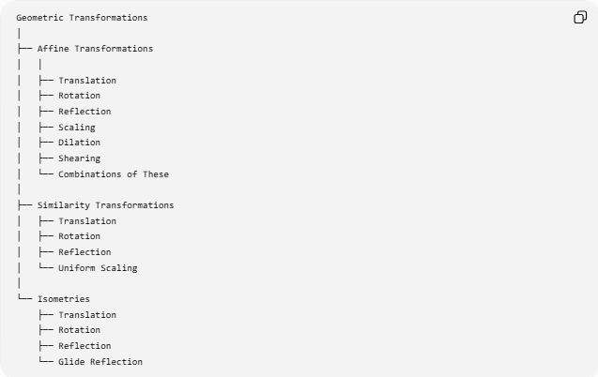
Geometric Transformations
│
├── Affine Transformations
│ │
│ ├── Translation
│ ├── Rotation
│ ├── Reflection
│ ├── Scaling
│ ├── Dilation
│ ├── Shearing
│ └── Combinations of These
│
├── Similarity Transformations
│ ├── Translation
│ ├── Rotation
│ ├── Reflection
│ └── Uniform Scaling
│
└── Isometries
├── Translation
├── Rotation
├── Reflection
└── Glide Reflection
More precisely:
$$\boxed{\text{Isometries}⊂\text{Similarities}⊂\text{Affine Transformations}}$$
in the usual Euclidean setting.

Affine Transformation and Inverse Transformation
# Source: AI Source: Provided by: [Data Path: Persons Table -> ID Column: 1, Name_En Column: Motasem Essam] -> From: [ChatGPT] on [7/25/2026]
If:
$$T\left(x\right)=Ax+b$$
and:
$$det⁡\left(A\right)≠0$$
then:
$$\boxed{T^{-1}\left(x\right)=A^{-1}\left(x-b\right)}$$
The inverse is also affine.
Therefore:
$$\boxed{\text{The inverse of an invertible affine transformation is affine.}}$$

Affine Transformation and Coordinate Geometry
# Source: AI Source: Provided by: [Data Path: Persons Table -> ID Column: 1, Name_En Column: Motasem Essam] -> From: [ChatGPT] on [7/25/2026]
Affine transformations are particularly important in coordinate geometry because they provide a general algebraic framework for transforming coordinates.
The basic form is:
$$\boxed{\left(\begin{matrix}x^{'} \\ y^{'}\end{matrix}\right)=\left(\begin{matrix}a & b \\ c & d\end{matrix}\right)\left(\begin{matrix}x \\ y\end{matrix}\right)+\left(\begin{matrix}e \\ f\end{matrix}\right)}$$
This single equation encompasses many familiar coordinate transformations.

Key Formulas
# Source: AI Source: Provided by: [Data Path: Persons Table -> ID Column: 1, Name_En Column: Motasem Essam] -> From: [ChatGPT] on [7/25/2026]
General affine transformation
$$\boxed{x^{'}=Ax+b}$$
2D form
$$\boxed{x^{'}=ax+by+c} \\ \boxed{y^{'}=dx+ey+f}$$
Invertibility
$$\boxed{det⁡\left(A\right)≠0}$$
Inverse
$$\boxed{T^{-1}\left(x\right)=A^{-1}\left(x-b\right)}$$
Area scaling
$$\boxed{A^{'}=∣det⁡\left(A\right)∣A}$$
Horizontal shear
$$\boxed{\left(x , y\right)→\left(x , +kyy\right)}$$
Vertical shear
$$\boxed{\left(x , y\right)→\left(x , kx+y\right)}$$
Uniform scaling
$$\boxed{\left(x , y\right)→\left(k , xky\right)}$$

Key Points
# Source: AI Source: Provided by: [Data Path: Persons Table -> ID Column: 1, Name_En Column: Motasem Essam] -> From: [ChatGPT] on [7/25/2026]
- An affine transformation has the general form:
$$x^{'}=Ax+b$$
- It preserves straight lines.
- It preserves collinearity.
- It preserves parallelism.
- It preserves ratios of directed lengths along a line.
- It preserves midpoints.
- A general affine transformation does not preserve lengths.
- A general affine transformation does not preserve angles.
- A general affine transformation does not necessarily preserve circles.
- A circle can become an ellipse.
- An invertible affine transformation requires:
$$det⁡\left(A\right)≠0$$
- The inverse of an invertible affine transformation is also affine.
- Translation, rotation, reflection, and uniform dilation are special cases of affine transformations.
- Shearing and non-uniform scaling are important examples of affine transformations that demonstrate what affine geometry preserves while Euclidean geometry does not.
- Affine transformations can be composed, and their composition remains affine.

Conclusion
# Source: AI Source: Provided by: [Data Path: Persons Table -> ID Column: 1, Name_En Column: Motasem Essam] -> From: [ChatGPT] on [7/25/2026]
An Affine Transformation is a broad class of geometric transformations represented by:
$$\boxed{x^{'}=Ax+b}$$
Its defining geometric feature is that it preserves the affine structure of a figure—especially straightness, collinearity, parallelism, ratios along lines, and midpoints—while allowing lengths and angles to change.
A useful way to remember the hierarchy is:
$$\boxed{\text{Isometry}⊂\text{Similarity}⊂\text{Affine Transformation}}$$
Thus, affine transformation provides a bridge between familiar Euclidean transformations and more general coordinate-based geometric transformations.

